Evolution

Established in 1946 by brothers Andy, Ned, and John Lynch, the Lochee Boys and Girls Club has been a cornerstone of the Lochee community in Dundee. Initially founded to provide local youth with access to activities such as football, gymnastics, and boxing, the club has continually adapted to meet the evolving needs of its members. Over the years, it has relocated several times within Lochee, always maintaining its presence in the heart of the community. Today, the club operates from its premises on Wellbank Lane, offering a safe and inclusive environment for young people to in sports and activities. As a registered charity (SC016531), the Lochee Boys and Girls Club is dedicated to promoting the mental, spiritual, physical, and social well-being of its members.

**Summary**

**Since 1946 to date the Lochee Boys and Girls Club has been evolving. The club plans to invest more than £500,000 into the Lochee community, by expanding its facilities to better serve the community's growing needs. Collaborating with local stakeholders, plans are underway to enhance gym and training areas and create additional community spaces. Our project will create positive change for individuals and the wider community by encouraging youth engagement in healthy lifestyles, teamwork, and discipline through sport. It will promote social cohesion by bringing together diverse groups to foster understanding, cooperation, and inclusion. A key focus will be on physical and mental wellbeing, providing safe spaces for exercise that contribute to both physical fitness and mental health improvements. The expansion will generate wider social benefits, this includes new opportunities for volunteer and create employment opportunities, creating avenues for coaching certifications, mentoring positions, and careers in sports and community development. Sustained benefits for the community will be achieved by reducing social isolation, enhancing local engagement, and improving overall health metrics.**

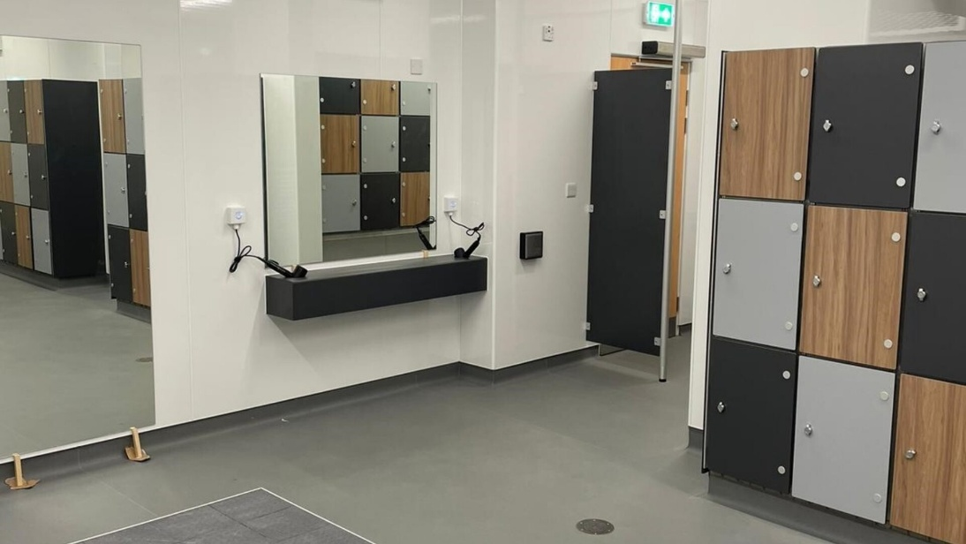

Create a new female changing area

