**WE ARE – THE DISC TARGET PROJECT**

**WHAT DO WE DO? –**

We Provide a safe place at nights where over 250 local youths can be safely diverted from harm, where they can congregate together in large numbers without causing alarm or fear to adults, and are provided with free football, free food, free football boots and free warm clothing.

**WHY DO WE NEED THIS MONEY FOR?**

We want to buy a Youth Shelter which can seat up to 50 youths every night. It will keep local young people dry we work with dry, diverted from harm, provided with hot and cold snacks and some young people out of trouble

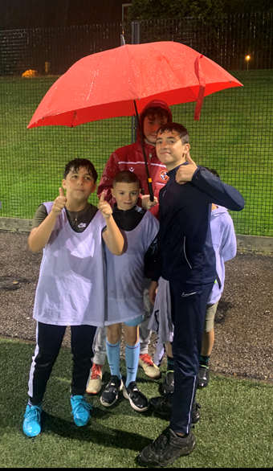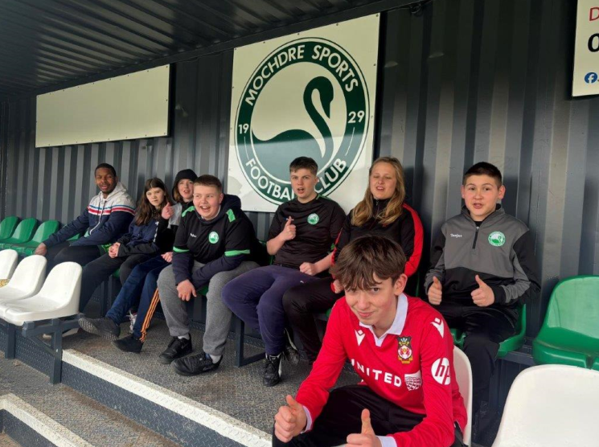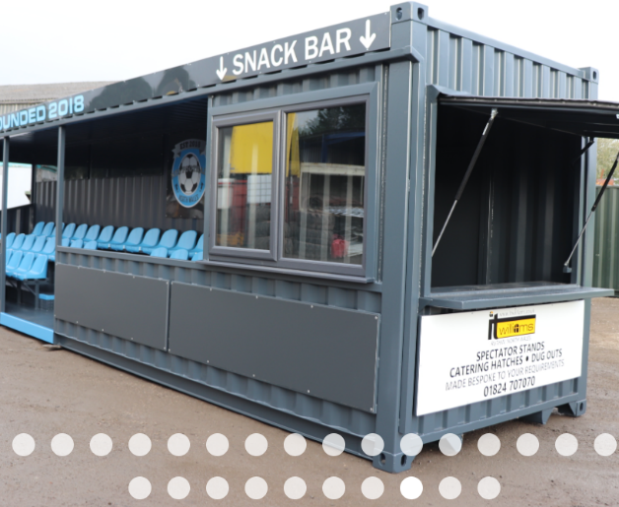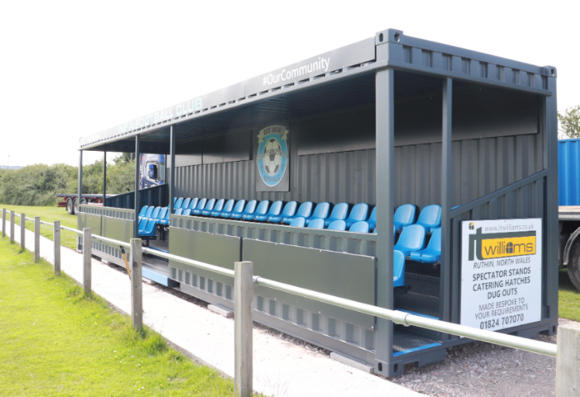Sadly, many of the 200 Youths that come to our outdoor Project every week are badly affected by Child Poverty. This means that many kids come to us cold, hungry, and without adequate warm waterproof clothing. When it rains, they do not have warm clothing to allow them to take part and often go home cold and hungry. This Youth Shelter would help us reduce the effects of poverty for many local young people,

**A SHELTER WOULD CREATE A DRY OUTDOOR SPACE WHERE LOCAL YOUNG PEOPLE AFFECTED BY POVERTY CAN SOCIALISE, STAY WARM AND DRY, RECEIVE FOOD, AND FEEL SUPPORTED BY THE LOCAL COMMUNITY.**

**HOT AND COLD FOOD COULD BE PROVIDED FOR KIDS LIVING IN POVERTY.**

**A SHELTER WOULD HELP US SAFELY DIVERT 200 YOUNG PEOPLE PER WEEK.**