Project Name

Community Seating - Albert Street and Stobswell West

Albany Benches

Quote

To supply and install Albany Seats onto hard surfaces with black coated finish.

Cost - 8 No at £920.00 each = £7,360.00 + vat = £8,832.00

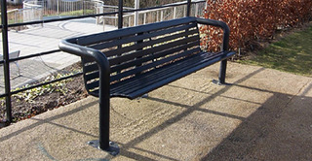

|  |  |
| --- | --- |
| Specification | |
| Height | 400mm |
| Length | 2050mm |

Areas for the benches

Albert Street across for Greens shop

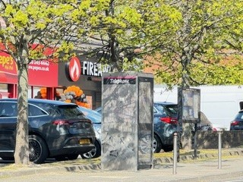 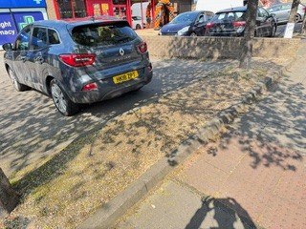

Sandeman Street Albert Street/Cardean Street

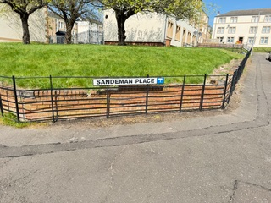 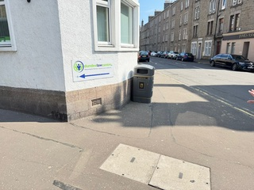

Arkley Terrace Court Street

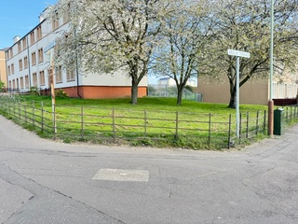 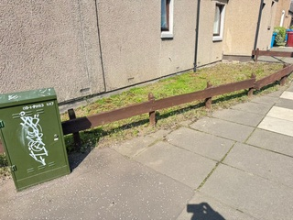

Strathmore Street Craigie Street

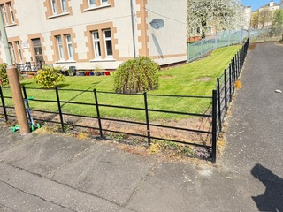 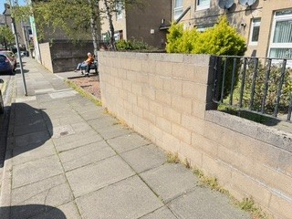

Eliza Street

