Thriving, Not Just Surviving: Small Steps to Systemic Change

The Dundee Fairness Initiative was a research and development programme commissioned by Dundee City Council (DCC) in the identified areas of Linlathen and Stobswell West in the City of Dundee, Scotland. These two areas were identified as a priority, because of data linked *inter alia* to the Scottish Index of Multiple Deprivation (SIMD) and because of issues linked to social inequalities and hence social justice. This report describes the work undertaken in Linlathen.

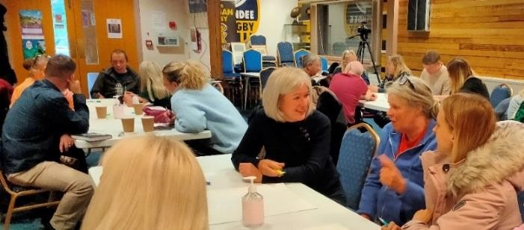

Linlathen has population of around 1870. 59% of people are of working age, 17% are elderly and 24% are children. 68% of homes are rented and 73% of dwellings are in Council Tax Band A. 62% of primary school children and 52% of secondary school children receive free school meals. One third of the population are prescribed drugs for anxiety, depression of psychosis (Source of Data: Dundee City Council).

Between July and December 2022, a multi-agency team from the DCC Community Empowerment Team, Brooksbank Centre, DCC Housing Department and Dundee Partnership worked together to find out, from the people who lived there, what it was like to live in Linlathen and what Dundee City Council and its partners could do to contribute to the well-being of residents. This report accompanies a film of the key research findings; which may be accessed [here.](https://vimeo.com/790496951/71ec292bc1)

Action research was selected as the method primarily because it has the potential for impact and change as part of its process through bringing together policy makers, practitioners, partners, residents and researchers. The team of local workers were given media and participatory research training. The team conducted 12 in-depth narrative interviews and 57 semi-structured questionnaire interviews, alongside photovoice and film making projects. They worked with local people themselves to make films about the area and the issues identified in the research. Together they called

themselves ‘Pitkerro Road Productions’ (referring to the main road running through Linlathen). These films can be

accessed below.

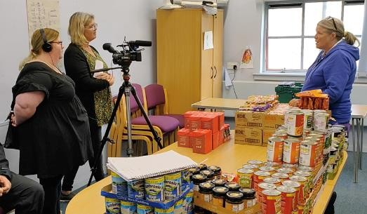

# Let’s Talk About

* [Employability Barriers](https://vimeo.com/757594036/366a96219b) (2 mins)
* [Housing](https://vimeo.com/757586763/51a4475133) (2.25 mins)
* [Green Space](https://vimeo.com/757555704/14ccdcccae) (2.5 mins)
* [Changing Values](https://vimeo.com/757588447/cd896cc751) (3 mins)
* [The Food Larder](https://vimeo.com/757567018/0270254cf7) (2 mins)

Further data was gathered by the Pitkerro Road Team at film screenings and fed into the research process. A [‘Making-of’](https://vimeo.com/759919993/acc875a6fc) film captured the filmmaking process and some of the impacts of the process for participants. This film explains the project and puts the films created during the research into context.

# The main findings from this research were:

### The population were eager to say they liked living in Linlathen and liked the look of the wooden houses. The presence of friends and good neighbours was clear. This was frequently, however, qualified with safety fears (drug addicts, anti-social youth behaviour) or with housing maintenance issues.

* It was clear from the data that the residents valued the environment and wanted it to be tidied up with greater green space; it was clear that this should be managed by the community, with support to set this up. Ideas ranged from development of a community garden, to allotments and litter picking. These small, arguably achievable, steps that can be taken were underpinned by broader systems issues. For example, the community garden was a concrete response to a sense of disempowerment; a sense of a lack of community spirit; and a view that the environment of Linlathen was controlled elsewhere, than in Linlathen itself.
* When asked what they liked least about Linlathen, housing particularly relating to cold and damp was prominent. The research found that housing insulation issues were a source of concern to residents and that Dundee City Council officials were already working on this issue. Council staff identified the problem as one of communication and a suite of initiatives were immediately undertaken to improve this, through letters to residents and local support for householders to report housing problems, a move reportedly valued highly by community residents.

### Thinking about food and fuel poverty, participants in the narrative inquiry often felt unable to look to the future; to see beyond the immediate crisis. So, methods of coping were food larders, cutting back on meals and wearing extra clothes in the house to stay warm. Systems issues contribute, of course, to this issue and small, arguably

achievable, steps are improving insulation for houses by refitting doors, but this does not take account of the wider systems issues of poverty that needs to be addressed.

* Many residents in Linlathen felt unable to overcome the significant barriers they faced in accessing employment. Barriers such as childcare costs; loss of benefits; lack of out of school care after Covid 19; and inflexibility of employment opportunities for those with families.
* Anti-social behaviour featured too along with an expressed need for there to be things for kids to do and a problem with motor-bikes. The main issues identified by young people allocated spaces on the fringes of communities include lack of transport, issues of safety and security, and feelings of exclusion.

*We are pensioners and we have a bit of savings.*

*I'm more worried about my daughter and the grand kids. We have been helping them out with their electricity bills, but it will soon eat into our savings.*

*People are*

*really nice here*

*We used to do lots as a family, but we*

*have cut down on activities for the kids*

*We have no money.*

*Not looking forward to Christmas*

*Wooden houses.*

*Heat or eat.*

# The recommendations of this research are:

### Fuel poverty is a significant issue for residents in Linlathen, continue with the cash first approach and progress with insulation and housing improvement.

1. The establishment of a Linlathen housing action sub-group of the Local Community Planning Partnership with representation from Dundee City Council and local residents.
2. Community green spaces or gardens to be established using a partnership approach between local community and local authority.
3. Develop a new youth work offer in Linlathen focusing on activities and improving the availability and accessibility of spaces for young people.
4. The need for the food larder will continue for the foreseeable future. Develop a plan to address food insecurity in Linlathen in a sustainable way.
5. In order to reduce social isolation and improve mental health and wellbeing, low cost or free learning activities should be available in Linlathen. Local community spaces are required for this to be achieved.
6. Employability should be tackled in a way that acknowledges the barriers to employment. Flexible and affordable childcare should be available for families seeking employment.
7. Residents experience multiple barriers to employment. As part of addressing this, opportunities to learn and develop skills should be available locally.

Residents should be enabled to participate in decisions and actions that affect them through ongoing involvement in a spirit of empowerment, by all service providers.

The research was implemented by members of CLD staff in Dundee City Council and this was done to good effect, both conscientiously and effectively. Thanks are due to all those who took part in the implementation and analysis of the project. We are also grateful to the 80+ residents who participated in the research process. We estimate that, in the six weeks of this research, a total of around 150 people were associated with the project. Local people were fundamental to the success of this initiative and we are particularly grateful to the team of action researchers from Linlathen for their time and commitment to the process.

# This research was carried out by:

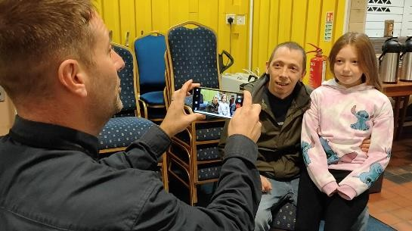

## Karen McArdle, FRSA,

### Professor Emeritus , University of Aberdeen Honorary Professor, University of Dundee [k.a.mcardle@abdn.ac.uk](mailto:k.a.mcardle@abdn.ac.uk)

**Iain Shaw**

Director

Media Education

[Iain@mediaeducation.co.u](mailto:Iain@mediaeducation.co.uk)k January, 2023