**Hope Education**

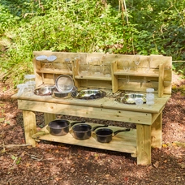

**[Outdoor L Shaped Mud Kitchen from Hope Education](https://protect.checkpoint.com/v2/r02/___https://www.hope-education.co.uk/product/early-years/outdoor/mud-kitchens-and-accessories/outdoor-l-shaped-mud-kitchen-from-hope-education-/he1827618___.YzJlOmR1bmRlZWNjOmM6bzo1MmRjYzAyY2ViNTNkMGIwM2MzOGZiOGE2ODg1Y2EyMzo3OjQ5N2E6YzcwZTVhMmM4ZGRlMjFiMzIxMmIxNzkwMzdiMGU3ODM5MGE3ZjAwMzE2MWQyNzdkYmNkOWM2Yjk2MGNlYjUzNTpwOlQ6Rg)**

*HE1827618*

**£1,399.99**

£1,679.99inc VAT

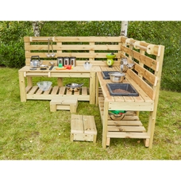

**[Outdoor Messy Kitchen from Hope Education](https://protect.checkpoint.com/v2/r02/___https://www.hope-education.co.uk/product/early-years/outdoor/mud-kitchens-and-accessories/outdoor-messy-kitchen-from-hope-education/he1496246___.YzJlOmR1bmRlZWNjOmM6bzo1MmRjYzAyY2ViNTNkMGIwM2MzOGZiOGE2ODg1Y2EyMzo3OmIwOGE6NTc1YmIyMGJkMTRjZWFmNzg5NWZmMGRjZTdiZWZkYjZhYWExMTYxODIzNGRmYWYwYzBjOWI5YmI3Y2Q3ZjQ0YjpwOlQ6Rg)**

*HE1496246*

**£469.99**

£563.99inc VAT

Product Datasheets

**Kompan**

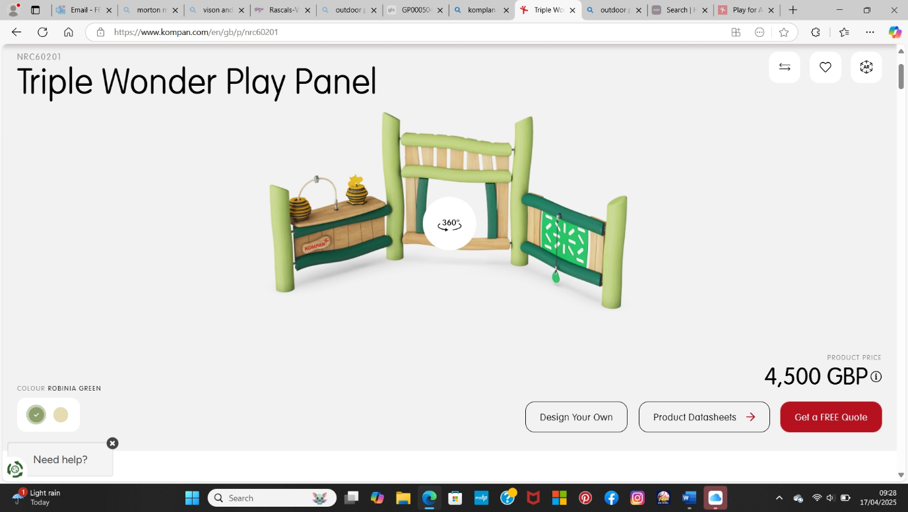

NRO871

Balance Plus

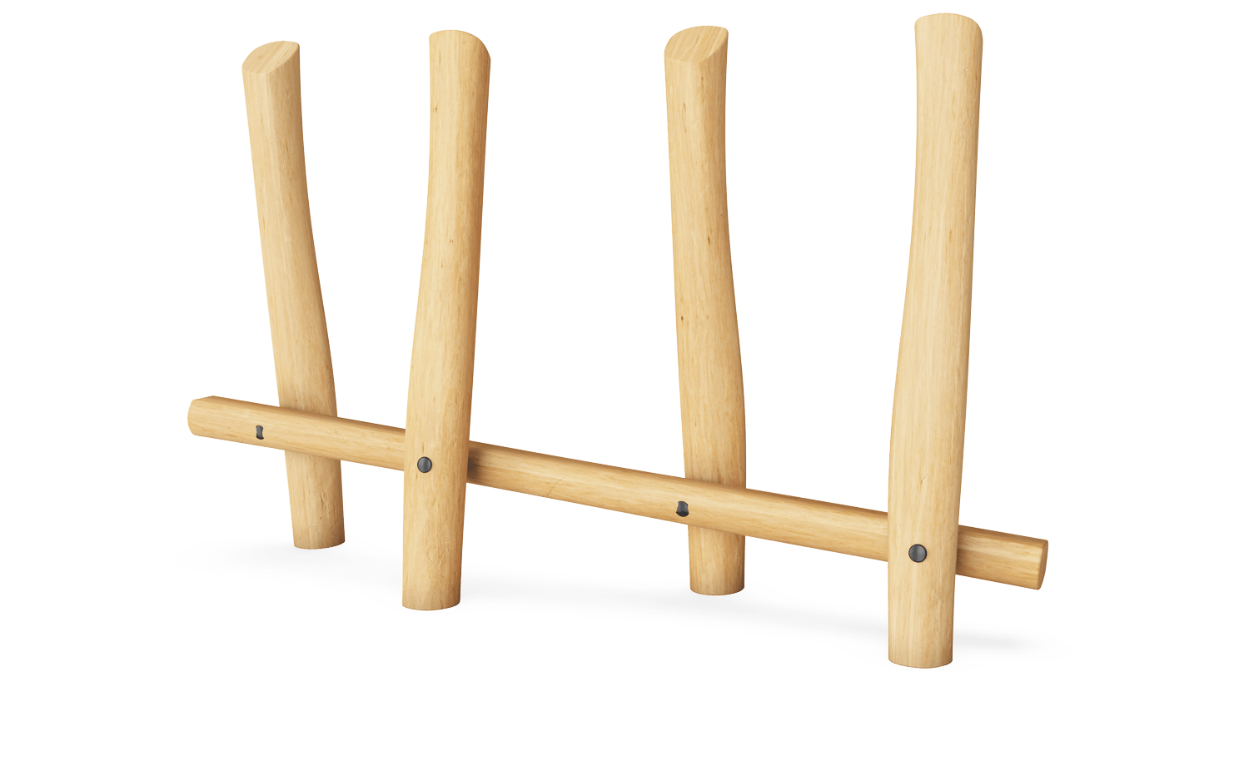

Colour ROBINIA UNT. WOOD

product price

1,150 GBP

Design Your Own

Product Datasheets

Get a FREE Quote

AR1006

Rumba Bench Curved 90°

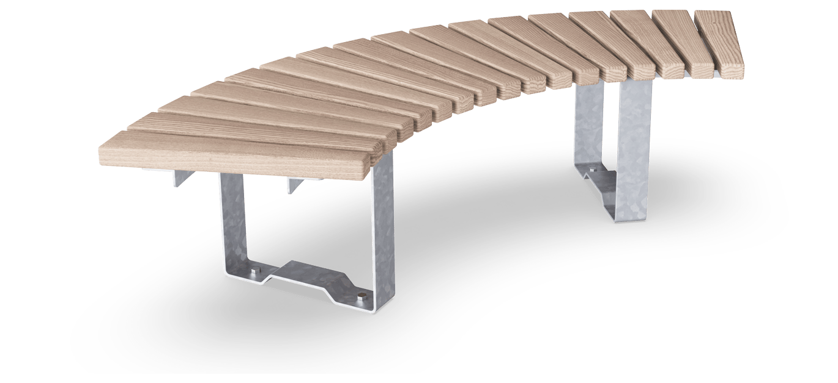

Colour ASH WOOD

product price

1,090 GBP

Design Your Own

Product Datasheets

Get a FREE Quote

PAR1003

Rumba Bench Curved 30°

Try our AR app

Reset camera

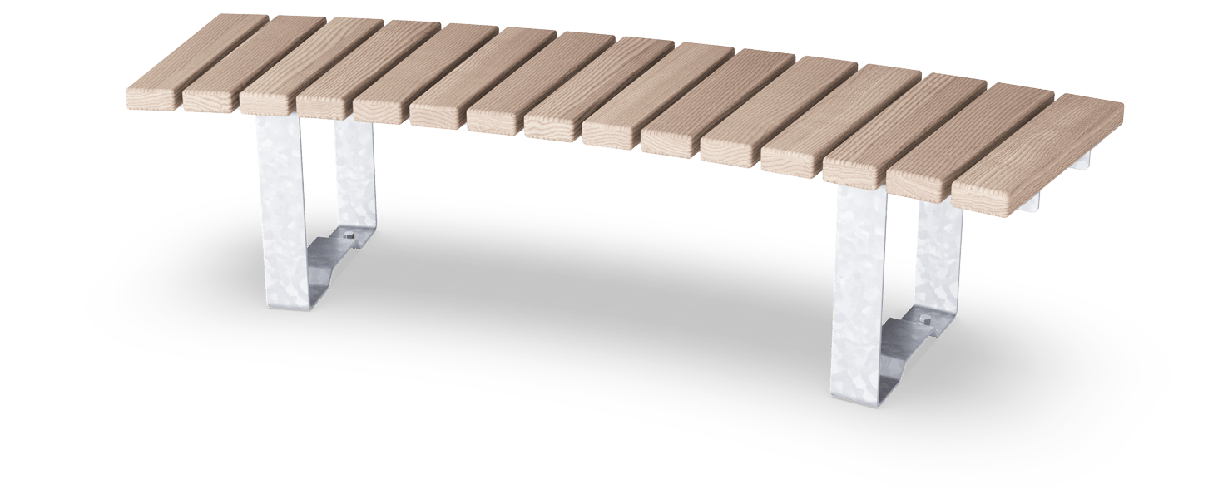

Colour ASH WOOD

product price

1,050 GBP

Design Your Own

Product Datasheets

Get a FREE Quote

PAR4051

Agora Bench with Backrest

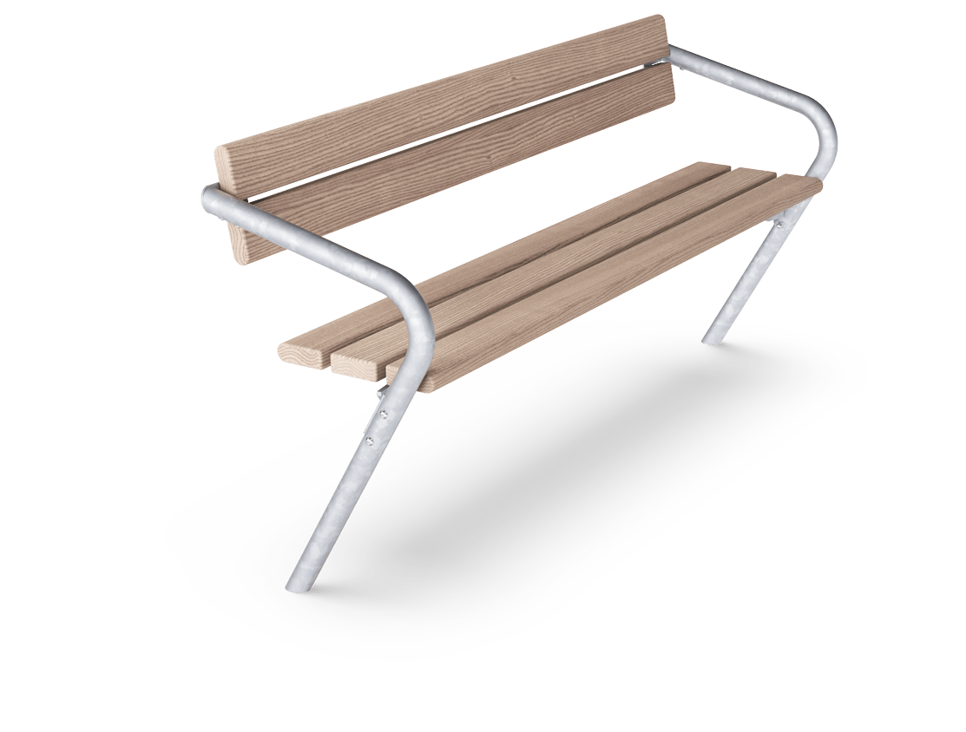

Colour METAL GREY

product price

890 GBP

Design Your Own

Product Datasheets

Get a FREE Quote

PAR1403

Anita Picnic - Inclusion

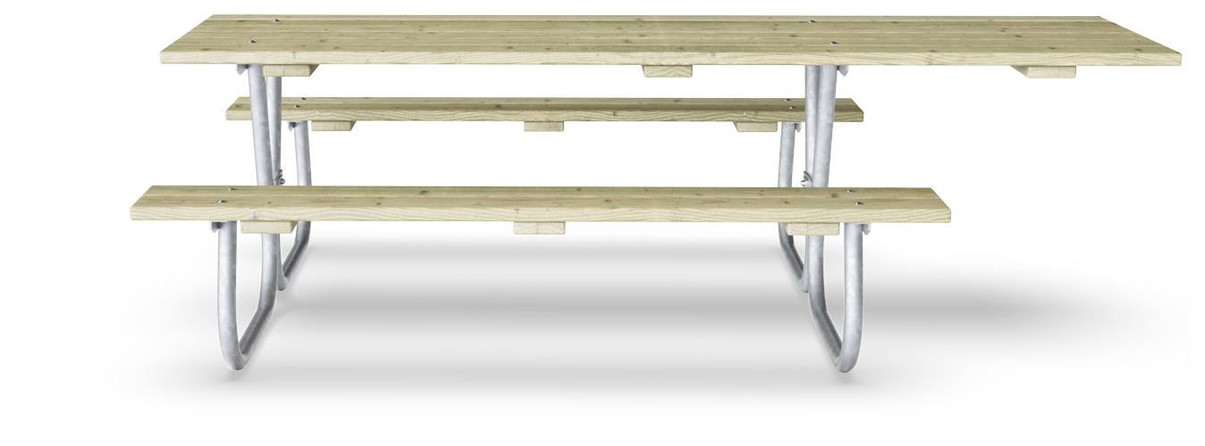

Colour PINE WOOD

product price

1,320 GBP

Design Your Own

Product Datasheets

Get a FREE Quote

**NBB Recycled Furniture**

Item

Price Each

Qty

Total

[**RFHJP03-MULTI x 2 - JUNIOR PICNIC TABLE SMALL 1200 x 1200mm MULTICOLOURED**](https://protect.checkpoint.com/v2/r02/___https://www.recycledfurniture.co.uk/Picnic-Tables/Early-Years-Junior-Picnic-Tables/Junior-Picnic-Table___.YzJlOmR1bmRlZWNjOmM6bzo1MmRjYzAyY2ViNTNkMGIwM2MzOGZiOGE2ODg1Y2EyMzo3OmM0ZjA6MjI0MDYyODU4OGQ4OTlkZjU4MzA2MTBhM2U4NDQ2N2QwNDNhZWFmN2Y4N2ZjMzFhZDk5MTQ5ZGFlZmYzMTY4NTpwOlQ6Rg)

Size: Small

Dimensions: L1200 x D1200mm

Capacity: 4-6 Person

Weight: 53kg

Pack Qty: 1 Table

**£470.00**

**Basket Bin IconUpdate £940.00**